EXPERIMENT-1 Simulation and Comparative
Performance Evaluation of Zigbee, 6LoWPAN and NB-IoT Communication Protocols for IoE Applications

Objectives:
To simulate and compare the performance of Zigbee, 6LoWPAN, and NB-IoT communication protocols for Internet of Everything (IoE) applications based on parameters such as data rate,
latency, energy consumption, communication range, and reliability

Procedure :
- Select a suitable simulation tool and configure the network environment for Zigbee, 6LoWPAN, and NB-IoT protocols.
- Create the network topology by configuring nodes, gateways, and communication links for each protocol.
- Simulate data transmission between IoE devices using the three communication protocols under similar conditions.
- Measure and record the performance parameters, including throughput, latency, energy consumption, and packet delivery ratio.
- Compare the simulation results and identify the most suitable protocol for different IoE applications based on its performance.

Table column:

 | ZIGBEE | 6LoWPAN | NB-IoT
Pt (dBm) | 1 | 1 | 22
PL₀ (dB) | 41 | 39 | 32
N | 3.1 | 2.9 | 3.4
Noise (dBm) | -104 | -106 | -104
BER | 3.125 × 10⁻¹⁷⁰ | 3.620 × 10⁻⁵¹ | 0.0038

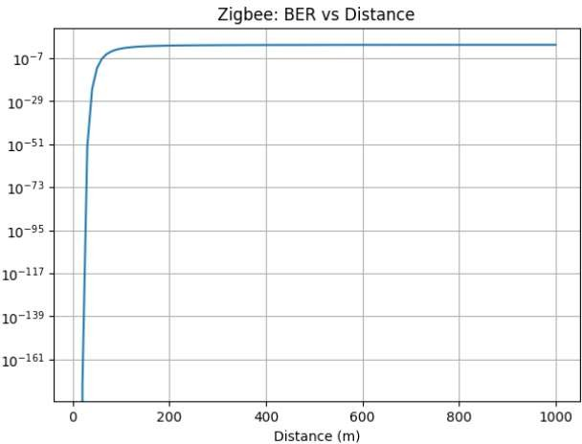
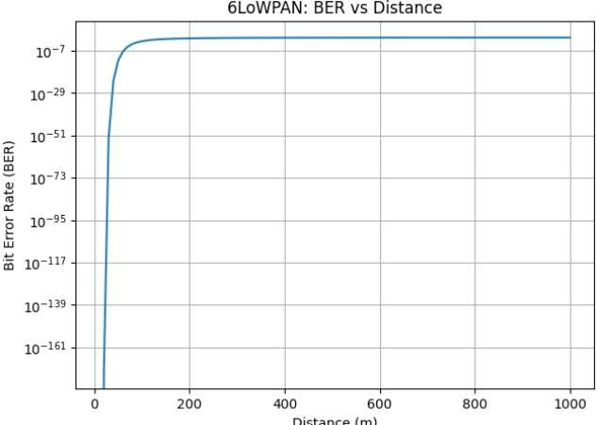

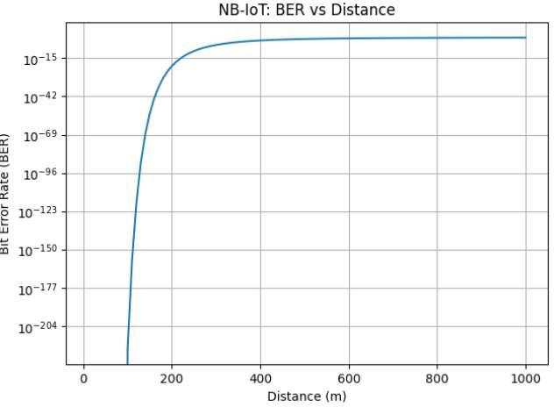

 | ZIGBEE | 6LoWPAN | NB-IoT
Pt (dBm) | 1 | 1 | 22
PL₀ (dB) | 41 | 39 | 32
N | 3.1 | 2.9 | 3.4
Noise (dBm) | -99 | -99 | -99
BER | 1.8520 × 10⁻³⁵ | 4.2160 × 10⁻¹¹ | 0.112

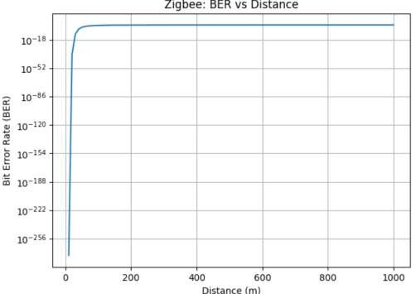

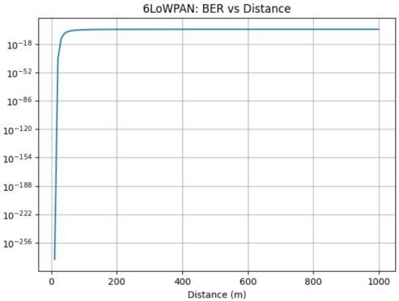

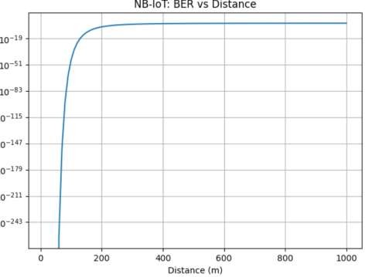

 | ZIGBEE | 6LoWPAN | NB-IoT
Pt (dBm) | 1 | 1 | 22
PL₀ (dB) | 41 | 39 | 32
N | 3.1 | 2.9 | 3.4
Noise (dBm) | -105 | -105 | -105
BER | 7.125 × 10⁻¹³⁴ | 1.236 × 10⁻⁴⁰ | 0.0087

